Claim Setup Rules

Exercise 1: Investigation

Answer the following questions about the segmentation rules in the sample data.

1. A property exposure is set to prop_low under what conditions?
2. What segment is a property exposure assigned to if the conditions for the Property Low, Property Medium, and Property High rules are all false?

Answer the following questions about the workplan rules in the sample data.

1. In the **Claim Workplan** rule set, every time the createActivityFromPattern method is called, the first argument is null. Why?
2. Most exposure types referenced in the sample rules cause only a single activity to be created. Which exposure type can cause two activities to be created?

Exercise 2: Configuration

Configure ClaimCenter to meet the following customer requirement from Acme Insurance.

**Requirement: Segmentation for Property Claim Fraud Detection**

Acme Insurance has experienced a rise of fraudulent property claims in which a loss occurred. For example, a new policy was issued and a loss was reported shortly after the policy came into effect. Acme wants to use claim segmentation to help identify claims which are possibly fraudulent in this way.

1. Modify the Claim Segment typelist by adding a typecode that has the name “Early Term Loss”, which will be visible in the UI.
2. This constitutes a change to the data model and you will need to restart the application server and regenerate your data dictionary.
3. Modify the claim segmentation rules such that if a property claim has a loss date which is within 30 days of the policy's effective date, the claim is segmented as an *“Early Term Loss”*. This takes precedence over all other property segmentation rules. Give the rule a name that is descriptive of its purpose and conforms to best practices for naming rule sets.
4. The segmentation rule needs a date library function.
5. If your segmentation rule segments the claim, then your code should exit the rule set.
6. Modify the claim workplan rules such that claims segmented as "Early Term Loss" will have two activities created:

* Get the property inspected activity (code: property_inspection)
* Make a diary entry in 90 days activity  (code: 90_day_diary)

1. Your solution should avoid creating duplicates of either of these activities. Therefore you need to determine if any existing rules create these activities.

Test Cases

When you have completed your configuration, run the following test cases:

1. Remember to run Make Project or Reload Changed Classes in Guidewire Studio before testing. Changes to gosu classes, enhancements, and rules are reloaded using this method, instead of using ALT+SHIFT+L. See the lab instructions for the **Introduction to ClaimCenter configuration** lesson for steps on running in a debug process in Studio.
2. Log on as Ronald Barnes (rbarnes). Using policy 23-502011, create a property claim whose loss date is up to 10 days after the policy effective date. Make sure to assign the claim to Ronald Barnes. Verify that:

- The claim is segmented as "Early Term Loss"

- The claim's workplan has a property inspection and a 90-day diary activity.

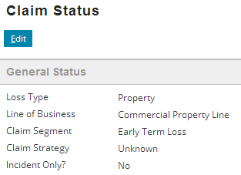 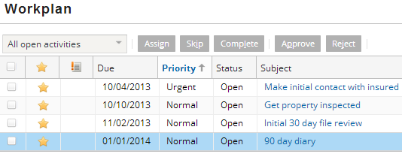

1. Using policy 23-502011, create a property claim whose loss date is two months after the policy effective date. Make sure to assign the claim to Ronald Barnes. Verify that:

* The claim is **not** segmented as "Early Term Loss"
* The claim's workplan **does not** have a property inspection and a 90-day diary activity.

